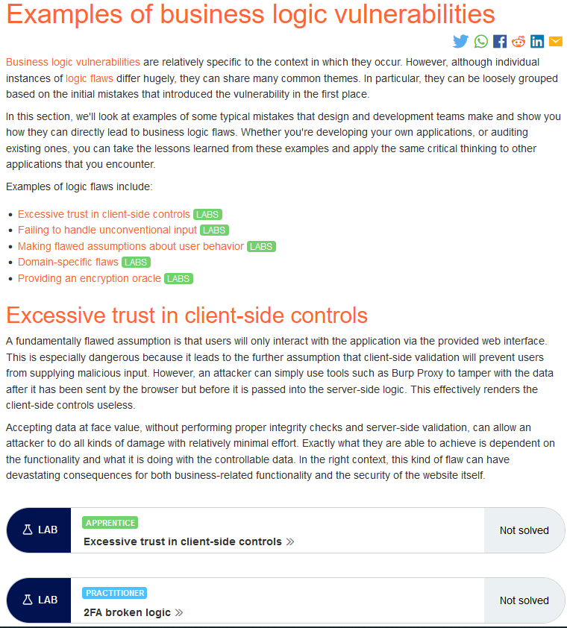The “brute forcer” payload option in burp is super useful for random permutations of a certain length and char set. Any like 4 digit password maybe or If we have a few letters/ digits and want to brute the rest